Assignment No -2
Git and GitHub: Repository Creation, Version Control, and Remote Repository Management

Aim
To understand the basic concepts of Git and GitHub by creating a local repository, tracking files, committing changes, connecting the repository to GitHub, and pushing the project to a remote repository.

Objective
- Learn Git version control.
- Create a local Git repository.
- Track project files.
- Commit project changes.
- Configure Git user details.
- Connect a local repository to GitHub.
- Push project files to a remote repository.
- Update and synchronize changes between local and remote repositories.

Theory
What is Git?
Git is a distributed version control system developed by Linus Torvalds in 2005. It helps developers track changes in source code, collaborate with team members, and maintain different versions of a project.
Features of Git
- Open Source
- Fast and Lightweight
- Distributed Version Control
- Branching and Merging
- Tracks File History
- Easy Collaboration
- Secure Data Storage

What is GitHub?
GitHub is a cloud-based hosting platform used to store Git repositories online. It allows multiple developers to collaborate on projects, manage versions, review code, and maintain project history.
Features of GitHub
- Repository Hosting
- Version Control
- Team Collaboration
- Pull Requests
- Issue Tracking
- GitHub Actions
- Project Management
- Open Source Contributions

Git Architecture
Working Directory
│
▼
Staging Area (git add)
│
▼
Local Repository (git commit)
│
▼
Remote Repository (GitHub)
GitHub Workflow Chart
START
│
▼
Create Project Folder
│
▼
git init
│
▼
Create/Edit Project Files
│
▼
git status
│
▼
git add .
│
▼
git commit -m "Commit Message"
│
▼
Configure Username & Email (if required)
│
▼
Create Repository on GitHub
│
▼
git remote add origin Repository_URL
│
▼
git branch -M main
│
▼
git push -u origin main
│
▼
Repository Uploaded Successfully
│
▼
Modify Files Whenever Required
│
▼
git add → git commit → git push
│
▼
END

Applications of GitHub
- Software Development
- Website Development
- Mobile App Development
- Machine Learning Projects
- Data Science Projects
- Academic Assignments
- Portfolio Hosting
- Open Source Contribution

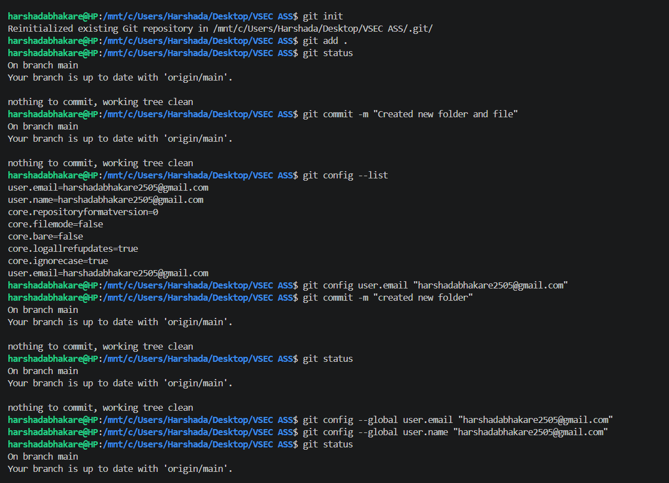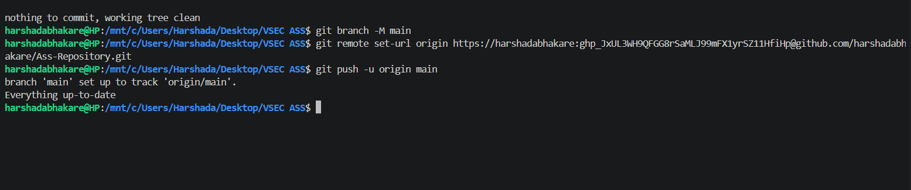

Conclusion
This assignment provided practical knowledge of Git and GitHub. It demonstrated how to initialize a repository, stage and commit files, configure Git user information, connect a local repository to GitHub, push updates, and resolve common errors. GitHub makes version control efficient and enables easy collaboration and project management.

